
Introduction to DOSBox
Lab 11

Computer Organization and Assembly Language

Student Name | Muhammad Hassan Khalid
Registration # | 21L-5692
Instructor | Hazoor Ahmad
Class | CS3
Section | A1, A2, D1, D2
Semester | Fall 2022

Fast School of Computing
FAST-NU, Lahore, Pakistan

Activity 1

Assembly Language Code
[org 0x0100]

jmp main

oldisr: dd 0 ; old isr offset and segment
buffer: times 2000 dw 0 ; buffer to save video memory

; to clear video screen
clrscr:
push es
push ax
push di

mov ax, 0xb800
mov es, ax
mov di, 0
nextchar:
mov word [es:di], 0x720
add di, 2
cmp di, 4000
jne nextchar

pop di
pop ax
pop es
ret

; to add some delay
delay:
push cx
push di

mov cx, 0xFF
delay1:
mov di, 0xFFF
delay2:
dec di
jnz delay2
loop delay1

pop di
pop cx
ret

; to store video memory in buffer
store_buffer:
push bp
mov bp, sp
push ax
push cx
push si
push di
push es
push ds

mov ax, 0xb800 ; points to video memory
mov ds, ax
mov si, 0
mov ax, cs
mov es, ax
mov di, buffer
mov cx, 2000

cld
rep movsw ; move data from video memory to buffer

pop ds
pop es
pop di
pop si
pop cx
pop ax
pop bp
ret

; load buffer
load_buffer:
push bp
mov bp, sp
push ax
push cx
push si
push di
push es
push ds

mov ax, 0xb800 ; points to video memory
mov es, ax
mov di, 0
; points to buffer
mov ax, cs
mov ds, ax
mov si, buffer
mov cx, 2000

cld
rep movsw ; load buffer in video memory

pop ds
pop es
pop di
pop si
pop cx
pop ax
pop bp
ret

; hook key board interrupt with interrupt chaining
kbISR:
push ax
in al, 0x60 ; read a char from keyboard

cmp al, 00011101b ; snap code of ctrl == 29
JNE nextCmp

CALL store_buffer ; store video memory in a buffer
CALL clrscr ; clear screen
jmp exit

nextCmp:
cmp al, 10011101b ; snap code of ctrl == 29
JNE noMatch

CALL delay ; add some delay
CALL load_buffer ; load buffer in video memory
jmp exit

noMatch:
pop ax
jmp far [cs:oldisr] ; CALL the original ISR

exit:
mov al, 0x20 ; send EOI
out 0x20, al
pop ax
iret

main:
xor ax, ax
mov es, ax
; save old keyboard isr
mov ax, [es:9*4]
mov [oldisr], ax
mov ax, [es:9*4+2]
mov [oldisr+2], ax

; hook keyboard interrupt
cli
mov word [es:9*4], kbISR
mov [es:9*4+2], cs
sti

; to make program TSR
mov dx, main
add dx, 15
mov cl, 4
shr dx, cl
mov ax, 0x3100
INT 0x21

Debugging Screenshots
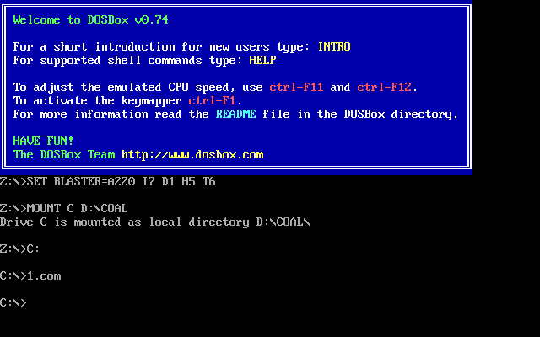

AFTER PRESSING CONTROL KEY

AFTER RELEASING CONTROL KEY



Activity 2

Assembly Language Code
[org 0x0100]

jmp start

ms: dw 0 ;Milli seconds

count: dw 0, 0, 0, 0, 0 ;Count of the characters typed

tCount: dw -1 ;Note: The tCount of first second is initialized to -1 for one time because when you type the command and press ENTER
; then the program gets loaded. And it takes you a few milliseconds to release the ENTER key
; and since the program was loaded before, it counts this release of ENTER key as one. So this release count
; is ignored by initializing the count to -1

iNo : dw 0

location: db 0 ;Location where the next star is to be printed

;-----------------------------------------------------------------------------------------------------------------

;Clear Screen
clrscr: pusha
push es

mov ax, 0xb800
mov es, ax
xor di,di
mov ax,0x0720
mov cx,2000

cld
rep stosw

pop es
popa
ret
;-----------------------------------------------------------------------------------------------------------------

;Program to print the stars
printStars: pusha
push es

mov ax, 0xb800
mov es, ax

mov al, 80
mul byte [cs:location]
add ax, 159
shl ax, 1

mov di, ax

mov cx, [cs:tCount]

cmp cx, 0
jle return

l1: mov byte [es:di], '*'
inc byte [cs:location]
add di, 160
loop l1

return: pop es
popa
ret

;-----------------------------------------------------------------------------------------------------------------

CTS: pusha

;These lines will execute for the very first five seconds
cmp word [cs:iNo], 10
jz l2

add word [cs:ms], 55
cmp word [cs:ms], 1000
jl EOI2

mov word [cs:ms], 0 ;Resetting the MilliSeconds to zero
call printStars ;Because the count is to be updated every second i.e
;the stars are to be printed after every second

mov ax, [cs:tCount]
mov bx, [cs:iNo]

mov word [cs:count + bx], ax

mov word [cs:tCount], 0
add word [cs:iNo], 2

jmp EOI2

l2: add word [cs:ms], 55
cmp word [cs:ms], 1000
jl EOI2

mov word [cs:ms], 0 ;Resetting the MilliSeconds to zero

;Shifting the counts towards the right, to create a space for this current second

mov dx, 0

mov ax, [cs:count + 2]
add dx, ax
mov [cs:count], ax

mov ax, [cs:count + 4]
add dx, ax
mov [cs:count + 2], ax

mov ax, [cs:count + 6]
add dx, ax
mov [cs:count + 4], ax

mov ax, [cs:count + 8]
add dx, ax
mov [cs:count + 6], ax

mov ax, [cs:tCount]
add dx, ax
mov [cs:count + 8], ax

jmp a1

EOI2: jmp EOI ;Intermediate Jump

;Now dx contains the count of the last five seconds

a1: mov [cs:tCount], dx

call clrscr

mov byte [cs:location], 0
call printStars

mov word [cs:tCount], 0

EOI: mov al, 0x20
out 0x20, al

exit: popa
iret

;-----------------------------------------------------------------------------------------------------------------

;Keyboard ISR

kbisr: push ax

in al, 0x60

shl al, 1
jnc EOI1

inc word [cs:tCount] ;If a key is released, only then increase the count

EOI1: mov al, 0x20
out 0x20, al

pop ax

iret

;-----------------------------------------------------------------------------------------------------------------

start: mov ax, 0
mov es, ax

mov bx, 0

call clrscr

;Hooking the interrupts
cli

mov word [es: 9*4], kbisr
mov [es:9*4+2], cs

mov word [es:8*4], CTS
mov [es:8*4+2], cs

sti

;Code for making it TSR
mov dx, start ;End of resident portion
add dx, 15 ;round up to next para
mov cl, 4
shr dx, cl ;number of paras

end: mov ax, 0x3100 ;terminate and stay resident
int 21h

Debugging Screenshots




